## Drowsiness Detection System

**A Project Work Synopsis**

*Submitted in the partial fulfillment for the award of the degree of*

#### BACHELOR OF ENGINEERING

**IN**

**COMPUTER SCIENCE WITH SPECIALIZATION IN**

**BIG DATA ANALYTICS**

**Submitted by:**

20BCS3880 K. Lohith Kumar

20BCS3953 K. Rajasekhar Reddy

**Under the Supervision of:**

**Prof. Shweta mam**



**CHANDIGARH UNIVERSITY, GHARUAN, MOHALI - 140413, PUNJAB**

**January 2024**

## Abstract

Transportation safety is important for the detection of Driver’s Drowsiness. Drowsy driving is a significant reason for traffic accidents. Driver Fatigue is one of the major reasons causing most fatal road accidents around the world. This shows that in the transportation industry especially, where a heavy vehicle driver is frequently open to hours of monotonous driving which causes fatigue without frequent rest periods. Hence, it's veritably essential to design a road accident prevention system for detecting driver’s sleepiness, which determines the position of motorist inattention and give a warning when an impending hazard exists. In this project, we give a real-time system using real-time image processing, face-eye detection techniques, and eye blink rates. The system is designed as an anonymous real-time monitoring system. The priority is on improving the safety of the driver without being intrusive. In this work, the eye blink of the driver is detected. However, the driver is said to be drowsy and an alarm is sounded, If the driver’s eyes remain unrestricted for further than a certain period of time. The programming for this is done in OpenCV using the Haar cascade library for the detection of facial features.

Keywords: Driver drowsiness, eye detection, yawn detection, blink pattern, fatigue.

**Table of Contents**

|  |
| --- |
| Title Page i |
| Abstract ii |
| 1. Introduction 1 |
| 1.1 Problem Definition 2 |
| 1.2 Project Overview 2 |
| 1.3 Hardware Specification 3 |
| 1.4 Software Specification 3 |
| 2. Literature Survey 3 |
| 2.1 Proposed System 5 |
| 3. Problem Formulation 6 |
| 4. Research Objective 7 |
| 5. Methodologies 7 |
| 6. Conclusion 9 |
| 7. Tentative Chapter Plan for the proposed work 10 |
| 8. Reference 11 |

# INTRODUCTION

In today's fast-paced world, road safety is a critical concern. Drowsy driving is a significant contributor to accidents, posing risks to both the driver and others on the road. To address this issue, the development of advanced driver assistance systems has become imperative. One such system is the "Drowsiness Detection System."

The attention position of a driver degrades because of lower sleep, long nonstop driving, or any other medical condition like brain diseases, etc. Several checks on road accidents say that around 30 percent of accidents are caused by the fatigue of the motorist. When a driver drives for a longer than normal period for mortal also inordinate fatigue is caused and results in a frazzle which drives the motorist to sleepy condition or loss of knowledge. Drowsiness is a complex miracle that states that there's a drop in caution and conscious situations of the driver. Though there's no direct measure to describe the drowsiness but several other indirect approaches can be used for this purpose. (Figure 1)

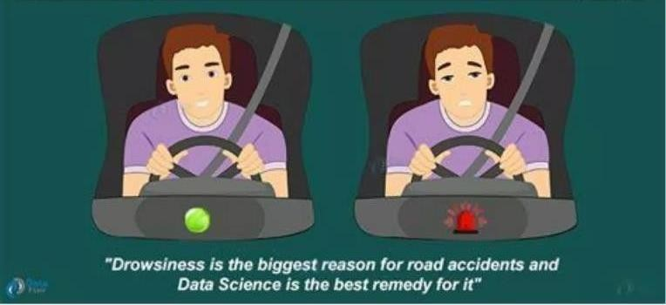

Figure 1

## Problem Definition

In India, drowsiness is the leading cause of business accidents. As a result, Drivers Drowsiness Detection System Using Webcam is enforced and used to reduce the number of accidents involving motorcars and lorries. When a driver is in a drowsy state, it identifies the drowsiness and give the beep alert to the driver.

## Problem Overview

Current drowsiness discovery systems, similar as Electroencephalography (EEG) and Electrocardiography (ECG), which descry brain frequency and measure heart meter, independently, bear complex calculation and precious outfit that's uncomfortable to wear while driving and isn't suitable for driving conditions.

A drowsiness detection system that uses a camera in front of the driver is more ideal for use, but the physical signals that indicate drowsiness must first be linked in order to develop a dependable and accurate drowsiness detection algorithm. During discovery of the eye’s issues crop due to lighting intensity and while the driver tilts their face left or right.

As a result, the thing of this design is to review all once exploration and styles, and present a system for detecting drowsiness using webcam. It examines the webcam images that have been captured and examine each frame of the video.

## Hardware Specification

Personal computer with keyboard and mouse maintained with uninterupted power supply.

* + - Processor: Intel® core™ i5
    - Installed Memory (RAM): 8.00 GB

## Software Specification

Operating System : WINDOWS 7, 8.1,10,11

Coding language : PYTHON

Web Browser : GOOGLE CHROME

### LITERATURE SURVEY

Drowsiness Detection of a Driver using Conventional Computer Vision Application (2020) In this paper, pre-existing features for facial landmark detection is used. The stepwise process of the system is shown in Figure 2. The methodology uses 68- facial landmark (a predefined landmark) for shape prediction in order to identify various regions of the face like eyebrows, eye, mouth region etc as shown in Figure 3.

The facial landmark recognition is carried out as follows:

* Input the image and clearly identify the face using Viola Jones Algorithm
* Clearly detect 68 points to identify (x,y) coordinate various region of the face.
* Localize the landmarks to detect eye, mouth region etc.
* Change in the shape of said region reports various expressions for drowsiness and fatigue.

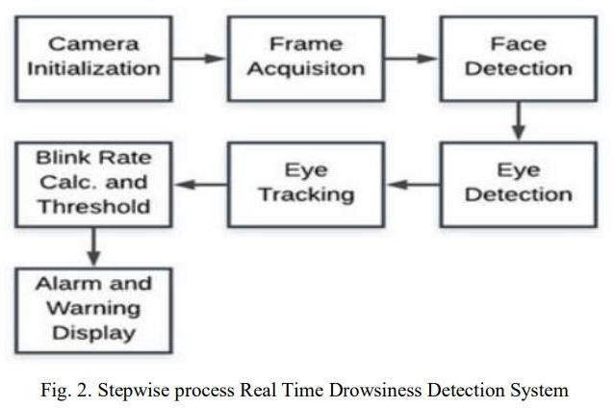

High vision cameras are embedded to monitor, capture, and extract frames one by one and generate the alerts accordingly. Each extracted frame is analyzed to study the pattern of facial features; using Haar Cascade Classifiers and determined Eye Aspect Ratio (EAR) and Mouth Aspect Ratio (MAR) for each frame. EAR and MAR values exceed their respective threshold values, a blink and a yawn is considered respectively. The system alerts the driver by playing an alarm if eye blinking rate and yawns are suspected for a certain number of consecutive frames. The alarm is activated to grab the driver's attention and keep on ringing until driver wakes up [3].

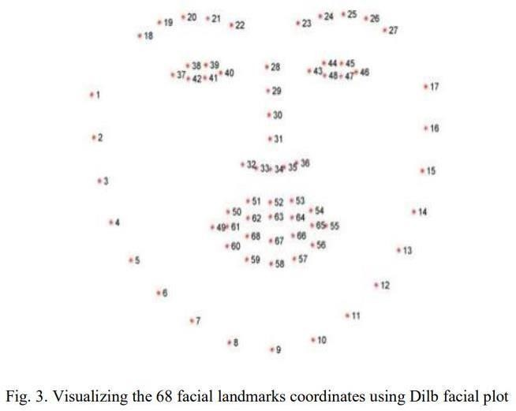

# PROPOSED SYSTEM

The proposed technique is primarily based on eye blinking of a driver which can be behavioral measures. The aim of this project is to detect closed eyes, this is to alert the driver. This is done by placing a camera or recording device in front of the driver and capturing real-time video continuously using OpenCV and dlib. The application is executed in Python and processing is done in the laptop's camera.

#### Eye Closure Detection:

Each eye is characterized by 6 coordinates as in figure 2.2. An equation called Eye Aspect Ratio (EAR) which reflects the relation between width and height of coordinators can be derived.

The distance between vertical eye landmarks is computed in numerator and those of horizontal eye landmarks are calculated in the denominator using the formula for Euclidean distance.



where p I ,p4 are endpoints of an eye,p2 and p3 are upper eyelid points , p6 and p5 are lower eyelid points.

This ratio of eye landmark distances can be used to determine whether a person is blinking or not.

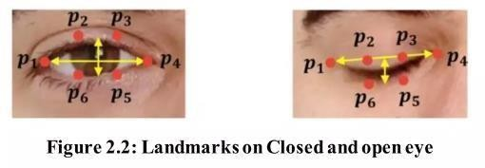

# PROBLEM FORMULATION

Our project is about making a clever system that helps people stay awake when they're doing important stuff like driving or working with machines. The challenge is to create a system that can notice when someone starts looking tired, like when they blink slowly or start nodding off. We want this system to make a noise or vibrate to wake them up or remind them to take a break before they get too sleepy.

The hard part is making sure the system works for everyone and doesn't give too many false alarms. We're using cameras and sensors to watch for signs of tiredness, like how someone's eyes move or if they're moving their head differently.

We're also trying to make the system smart so it learns when each person usually gets tired. That way, it can give the right reminders at the right times. And we're thinking about how the system will let people know they need to wake up – maybe with a beep or a buzz.

Lastly, we're making sure that all the information we collect is kept private and safe, following the rules to protect people's data.

To sum it up, we're creating a smart system to help people stay awake when it matters most.

# OBJECTIVES

The goal of drowsiness detection is to make sure that people don't get too sleepy when they need to stay awake and alert. This is important when doing things like driving, working with machines, or staying focused on important tasks. The detection system watches for signs like blinking slowly, nodding off, or changes in the way someone is driving. When these signs show up, the system gives a signal to wake the person up or take a break. This helps prevent accidents and keeps everyone safe.

# METHODOLOGY

The methodology of this project is the first video is captured using a webcam and from the video first face is detected using the Harcascade algorithm and then the eyes are detected. Then we use our deep learning model which is built using transfer learning to know the status of the eye. If it is an open eye then it will say Active and if it is a closed eye then it will check for a few seconds and then it will say the driver is drowsy and will beep an alarm.

We will use Python, OpenCV, TensorFlow, and Keras to build a system that can detect the closed eyes of drivers and alert them if ever they fall asleep while driving. If the driver’s eyes are closed, this system will immediately inform the driver. OpenCV that we are going to use now will monitor and collect the driver’s images via a webcam that was attached and feed them into the deep learning model and then the model will classify the driver’s eyes as ‘open’ or ‘closed.’ (Figure 4)

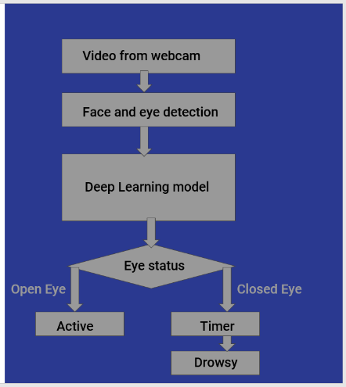

Figure 4

# CONCLUSION

This project looks at how to detect tiredness in a driver in real time by looking at eye closure. This technology has the advantage of detecting tiredness early on and sounding an alarm before an accident occurs. The use of OpenCV is more suitable for this application based on the design of the proposed work because it meets the relevant requirements such as cost, power, and size. Face, eye are easily detected by this technology, and these are captured using a webcam. The technology can detect whether the eyes open or closed during monitoring. A warning signal will be issued if the eyes have been closed for an extended period is detected.

1. **TENTATIVE CHAPTER PLAN FOR THE PROPOSED WORK**

#### CHAPTER 1: INTRODUCTION

This chapter will cover the overview of Drowsiness Detection.

#### CHAPTER 2: LITERATURE REVIEW

This chapter include the literature available for Drowsiness Detection. The findings of the researchers will be highlighted which will become basis of current implementation.

#### CHAPTER 3: OBJECTIVE

This chapter will provide introduction to the concepts which are necessary to understand the proposed system

#### CHAPTER 4: METHODOLOGIES

This chapter will cover the technical details of the proposed approach.

#### CHAPTER 5: EXPERIMENTAL SETUP

This chapter will provide information about the subject system and tools used for evaluation of proposed method.

#### CHAPTER 6: CONCLUSION AND FUTURE SCOPE

The major finding of the work will be presented in this chapter. Also, directions for extending the current study willbe discussed.

### REFERENCES

[I] S. R. Paul, NHTSA's Drowsy Driver Technology Program, 2005.

1. https://en.wikipedia.org/wiki/Driver drowsiness _ detection
2. Hitendra Garg Drowsiness Detection of a Driver using Conventional Computer Vision Application, 2020 International Conference on Power Electronics & IOT Applications in Renewable Energy and its control (PARC), Mathura, Uttar Pradesh, India.
3. Qaisar Abbas Hybrid Fatigue: A Real-Time Driver Drowsiness

Detection using Hybrid Features and Transfer Learning, International Journal of Advanced Computer Science and Applications, vol. 11, No. 1, 2020

1. Shruti Mohanty, Shruti V Hegde, Supriya Prasad, J. Manikandan Design of Real-Time Drowsiness Detection System using Dlib, 2019 5th IEEE International WIE Conference on Electrical and Computer Engineering, 15-16 Nov 2019, Bangalore, India.
2. Camera, 2019 1st International Symposium on Instrumentation, Control, Artificial Intelligence and Robotics, Bangkok, Thailand.